A000-Am, S-Peru-Wari-Figure-Vessel-Ceramic-600 CE

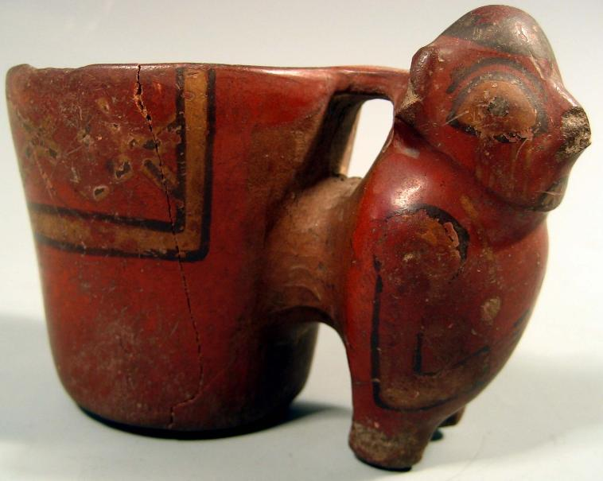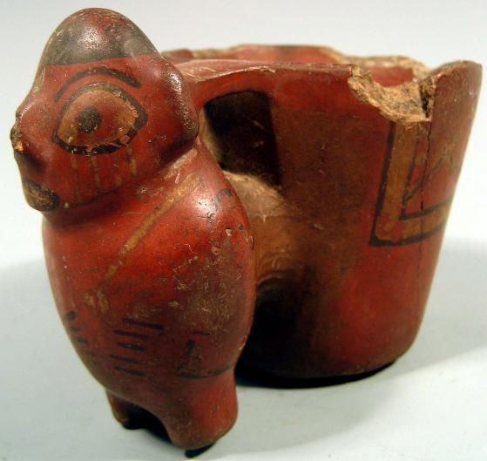

Am, S-Peru-Wari-Figure-Vessel-Ceramic-600 CE

Case No.: 14

**Accession No.**

**Formal Label:**

A Fine Ancient Pre Columbian Peru Southern Highlands Wari (Huari) Figural Pottery Vessel ca. 600 CE. The double body vessel with Figural handle the body painted in red with black accents signifies a cosmological scheme. The example measures 3 X 4.33 in. and has sustained losses, with cracks and repairs.

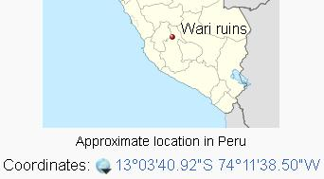The **Wari** (Spanish: *Huari*) were a Middle Horizon civilization that flourished in the south-central Andes and coastal area of modern-day Peru, from about CE 500 to 1000. (The Wari culture is not to be confused with the modern ethnic group and language known as [Wari'](http://en.wikipedia.org/wiki/Wari'), with which it has no known link.) [Wari](http://en.wikipedia.org/wiki/Wari_ruins), as the former capital city was called, is located 11 km (6.8 mi) north-east of the modern city of [Ayacucho](http://en.wikipedia.org/wiki/Ayacucho), Peru. This city was the center of a civilization that covered much of the highlands and coast of modern Peru. The best-preserved remnants, beside the [Wari Ruins](http://en.wikipedia.org/wiki/Wari_ruins), are the recently discovered [Northern Wari ruins](http://en.wikipedia.org/wiki/Northern_Wari_ruins) near the city of [Chiclayo](http://en.wikipedia.org/wiki/Chiclayo,_Peru), and Cerro Baul in [Moquegua](http://en.wikipedia.org/wiki/Moquegua). Also well-known are the Wari ruins of *Pikillaqta* ("Flea Town"), a short distance south-east of [Cuzco](http://en.wikipedia.org/wiki/Cuzco) *en route* to [Lake Titicaca](http://en.wikipedia.org/wiki/Lake_Titicaca).

* Pachacamac, located in the Lurin Valley, may have been in use as a sacred oracle site from the 1st millennium BCE while its settlement began sometime in the early 1st millennium CE. The god Pachacamac, also known as the ‘Maker of the Earth’, was a creator god who was also associated with earthquakes. In coastal mythology, Pachacamac had defeated the rival creator god Con who had stopped all rainfall as punishment for humanity’s wickedness.
* 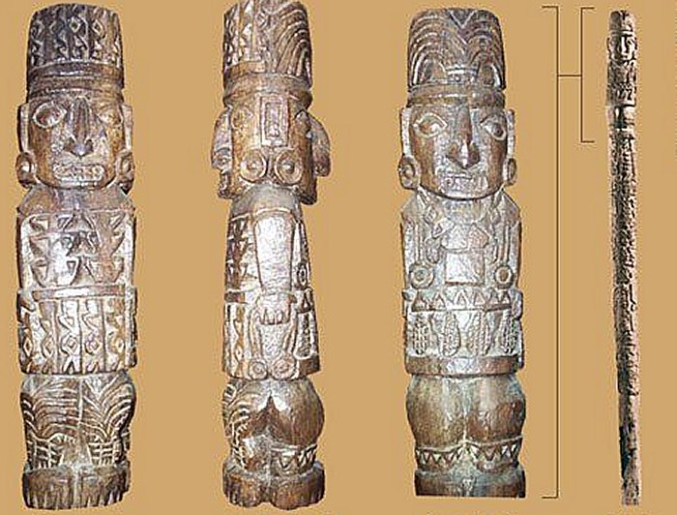
* God Pachacamac after <http://www.ancientpages.com/wp-content/uploads/2018/05/pachacamacsite15.jpg>
* Pachacamac then changed the existing human race into animals and created a whole new race of men and women. In some versions of the myths the god sent four stars to earth, the two male stars became the kings and nobility while the two female stars became the commoners.
* The god’s sacred wooden statue was worshipped at the site, situated inside a large temple complex built on a stepped earthen platform. This structure is contemporary with the Moche and Nazca civilizations (200 BCE – 600 CE). Built overlooking a colonnaded plaza and sitting on an eight-level platform on a natural hill, the temple buildings must have dominated the site. Each level of the adobe brick platform is around one meter high, and they were painted in bright colors with plant and animal designs. The figures were made more striking by outlining them in black. A set of artist’s brushes (of human hair and reeds) and a bag of pigments were found buried at the site in 1935 CE. The temple was well-maintained as some areas of decoration show as many as 16 re-coats. Buildings on the highest platform were arranged around a courtyard, and some were used as accommodation.
* The site attracted pilgrims from far and wide to consult its oracle although just how this functioned is not known in detail. We know that a High Priest interpreted the oracle from the privacy of a chamber only he was permitted to enter. Pilgrims had to undergo many weeks of initiation, fasting and cleansing rituals before they could be considered worthy of consulting the oracle. They were also expected to make offerings such as foodstuffs, coca, textiles, and any other precious goods they could afford. Indeed, the priests of Pachacamac established a network of subsidiary shrines throughout the region which extracted tributes from local populations. As at ancient oracles the world over, questions posed would have concerned the weather for agricultural purposes, warfare, health issues, family problems, and so on.
* Such was the popularity of the site that the historian Alden Mason described Pachacamac as ‘the Mecca of Peru’. This is attested by the finds in tombs of pottery and textiles coming from many different cultures such as the Lambayeque, Nazca, Wari, Tiwanaku, and Chimu. Eventually, the religious buildings spread with many shrines to lesser deities and a residential area sprang up to cover an area of 4 square miles (c. 10 square km). It thus became the largest center in central and southern Peru. In the residential zones many of the floors and column bases, which must have supported roofs of matting, survive.
* **LC Classification: F3430.1.H83**
* **Date or Time Horizon: 600 CE**
* **Geographical Area: Pachacamac**
* **Map:**
* **GPS coordinates:** [12°15′24″S 76°54′01″W](https://tools.wmflabs.org/geohack/geohack.php?pagename=Pachacamac&params=12_15_24_S_76_54_01_W_type:landmark)
* **Cultural Affiliation: Wari**
* **Media: ceramic**
* **Dimensions: W** 3 X 4.33 in
* **Weight:**
* **Condition: original**

**Provenance:** From an old New York City collection (of Nelson Rockefeller).

**References:**

Nawpa Pacha. 29:101-118. (2008)

Appendix: Other Views

